TC-CMS-021
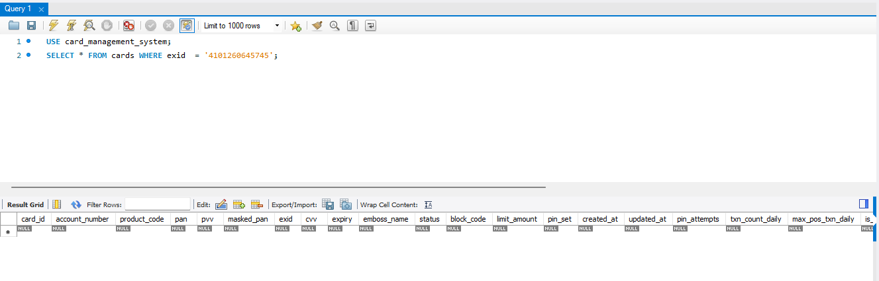
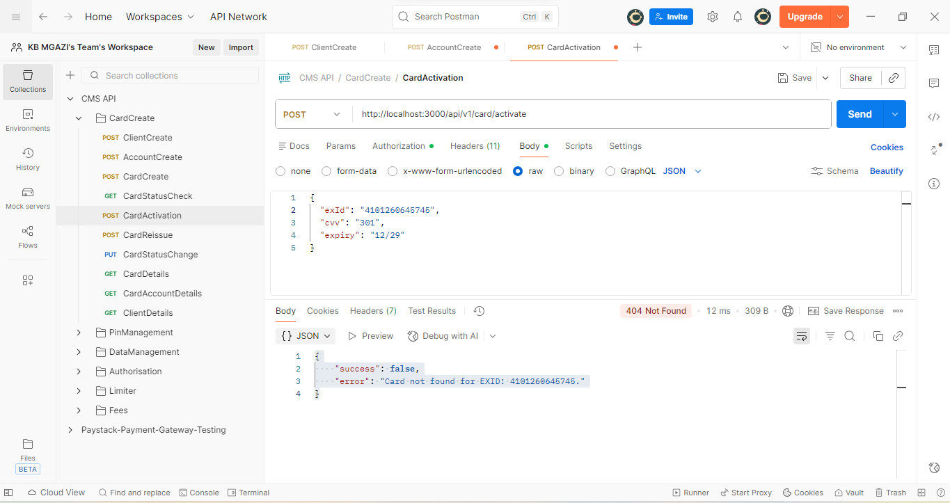
Request:
{
"exId": "4101260645745",
"cvv": "301",
"expiry": "12/29"
}

Response:
{
"success": false,
"error": "Card not found for EXID: 4101260645745."
}

